Worksheet 3 -- RegARIMA Diagnostics

The file H:\X13\data\retail\Furniture and home furnishings stores.dat lists retail sales from these stores.

Create a spec file for H:\X13\data\retail\Furniture and home furnishings stores.dat using the default options. By default, the program will choose a transformation, test for trading day and Easter, look for AO and LS outliers, and automatically choose an ARIMA model. It writes a new spec file with the results of these tests hard-coded.

See …/retail/Furniture and home furnishings stores.spc

Run the new Furniture and home furnishings stores.spc spec file in graphics mode. Use the log file, the output file, or the diagnostics screen to answer the following questions.

- What ARIMA model did the program choose?
(0 1 0)(0 1 1) -- from the output, Win X-13 Diagnostics, or the spec file itself

- Which regressors did the tests choose to include? Are they all significant?

Regression Model
Regression Model
 | Parameter  Estimate | Standard  Error | t-value
Constant | -0.0001 | 0.00045 | -0.31
Trading Day
Mon | -0.0019 | 0.00164 | -1.14
Tue | 0.0034 | 0.00160 | 2.13
Wed | 0.0025 | 0.00159 | 1.58
Thu | 0.0022 | 0.00160 | 1.40
Fri | 0.0091 | 0.00161 | 5.65
Sat | 0.0018 | 0.00161 | 1.09
* Link to definition of * Sun (derived) | -0.0172 | 0.00161 | -10.66
AO2000.Dec | -0.0624 | 0.01232 | -5.06

F Tests for Trading Day Regressors
 | df | F-statistic | P-Value
Trading Day | 6, 261 | 63.95 | 0.00

The constant is not significant (t = -0.31) but trading day is (as a group) and the additive outlier in December 2000 is (t = -5.06). This information is also available in the Model Info tab of the Win X-13 Diagnostics (columns have been rearranged):
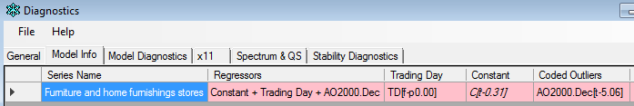

- What was the AICC? The average forecast error over the last three years?
The AICC = 3433.58, and the average forecast error over 3 years = 2.28%

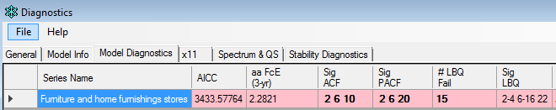

- Were any lags of the ACF or PACF significant?
Lags 2, 6, and 10 of the ACF and 2, 6, and 20 of the PACF. (Answers can also be found on output but they are more clear and easily found in the diagnostics and graphs.)
See graph below:

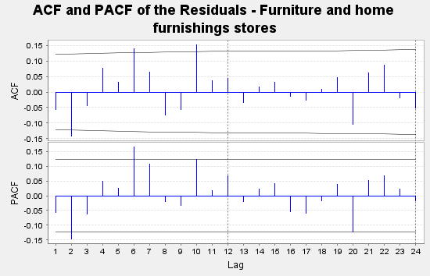

- At how many lags was the Ljung-Box Q significant?
15 lags

Open the spec file Furniture and home furnishings stores.spc. Remove any insignificant regressors. Change the ARIMA model to (0 1 2)(0 1 1). Select the red arrow next to the Run button. Check the box for ‘Output name’ and in the box next to it, type in Furniture and home furnishings stores – 012. Press Run.

- Why might we think changing the model to (0 1 2)(0 1 1) would be good to try?
The ACF & PACF are both significant at lag 2, indicating some autocorrelation remaining in the residuals after they were fit with the model (0 1 0)(0 1 1). Therefore we might try an (0 1 2)(0 1 1) model to attempt to model that autocorrelation.

- Look at the ARIMA model parameters. Are they all significant?
The MA parameter at lag 1 – θ₁ – is 0.08, which is between one and two standard errors of zero. This isn’t significant in the traditional statistical sense – greater than two standard errors from zero – but it is large enough that we wouldn’t want to skip it in a skipped lag model.

ARIMA Model
 | Estimate | Standard Error
Nonseasonal MA
Lag 1 | 0.08253 | 0.05974
Lag 2 | 0.12857 | 0.06037
Seasonal MA
Lag 12 | 0.61689 | 0.04979

The MA parameter at lag 2 – θ₂ – is greater than two standard errors from zero.

- Were any new outliers found?
No.

- Is it valid to use AICC to compare these two models? If yes, then which model is preferred?
Yes; they have the same model span, outliers, and order of differencing.
The AICC is smaller for the (0 1 2)(0 1 1) model, by almost 5.

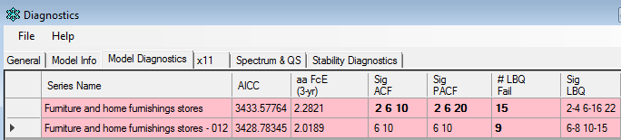

- Is it valid to use the average forecast error over the last three years to compare these two models? If yes, which model is preferred?
It is always valid to use this for model comparisons.
The (0 1 2)(0 1 1) model results in slightly smaller forecast errors.

- Were any lags of the ACF or PACF significant?
Yes, at 6 and 10. These are not lags we worry about.

- At how many lags was the Ljung-Box Q significant?
9 lags

Use Win X-13 to create a new spec file with automatic settings for Furniture and home furnishings.dat, but this time change the model span so that only the data from January 2005 are modeled. Name the new spec file Furniture and home furnishings stores – MS2005.spc. Run the spec file, and answer the following questions.
See ../retail/Furniture and home furnishings stores – MS2005.spc

- What model did the program choose? What regressors (including outliers) were included in the model?
(0 1 0)(0 1 1). Trading day (TD) was the only regression effect.

- Compare the seasonal MA parameters of the three models. Has it changed over time?
Yes; it was in the 0.61-0.64 range when the model span started in 1992. It’s about 0.48 when the model span starts in 2005.

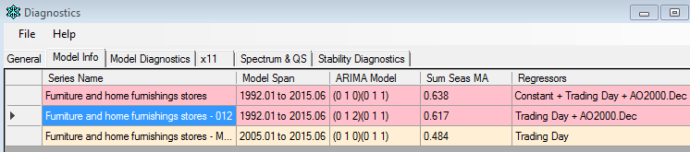

- Is it valid to use AICC to compare this model with the first model? If yes, then which model is preferred?
No. The model span and the outliers are different.

- Is it valid to use the average forecast error over the last three years to compare these two models? If yes, which model is preferred?
Yes, it’s always valid to make that comparison. The forecast errors are smallest with the final model.

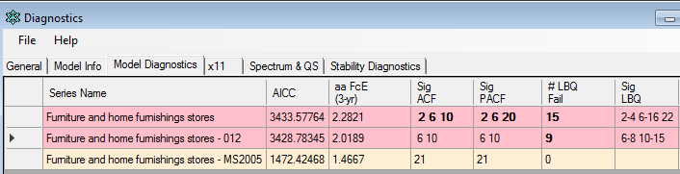

- Were any lags of the ACF or PACF significant?
Lag 21 of the ACF and PACF.

- At how many lags was the Ljung-Box Q significant?
None (Zero)
Create an out-of-sample forecast error plot to compare the first and third models:

- Start X-13-Graph by double clicking on the icon.
- Press ‘Add Series’ and select Furniture and home furnishings stores.gmt and Furniture and home furnishings stores – MS2005.gmt from the directory H:\x13\data\g\. Press ‘Open’ to add the series to the series list box.
- Use the Control button to select both the series from the series list box.
- In the Graph Types drop down box, select ‘History Graphs to Compare Two Models.’ From the graph list box, select ‘Sum of Squared Forecast Error Differences’ and press ‘Graph.’

Does the graph prefer one model to the other?

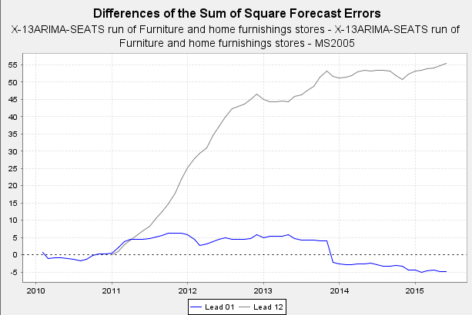

At first glance, it looks like Lead 12 strongly prefers the second model, the one with the shorter model span (an increasing slope indicates consistently positive squared forecast error differences, so forecast errors are larger for Model 1). Lead 1 looks more inconclusive.

However, most of the Lead 12 preference for Model 2 was from 2011 to 2012. Looking at the last couple of years:
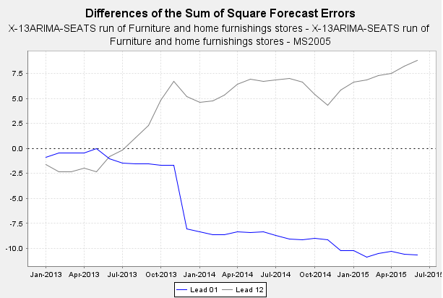
Lead 12 still shows a minor preference for Model 2, but Lead 1 indicates a minor preference for Model 2. The graph seems inconclusive.

Which of the three models do you prefer?

On the whole, diagnostics seem best for the third model.

